

Nebuchadnezzar’s Dream (Daniel 2)

Main Point: The Kingdom of God will last forever.

Key Verse: “In the time of those kings, the God of heaven will set up a kingdom. It will never be destroyed . . . it will last forever.” Daniel 2:44

Materials: Picture cards of homes where people might live

Personal Connection:
- Say: How many of you remember the story of the three little pigs? The wolf was terrorizing the three pigs at the door of each of their homes. Do you remember what the first house was made from? (Straw) When the wolf huffed and puffed, what happened to the house? (The wolf blew it down.) What was the second house made out of? (Sticks) What happened when the wolf huffed and puffed? (He blew the house down.) When he got to the third house, what was it made from? (Bricks) What happened when he huffed and puffed? (It didn’t fall down and the three little pigs were safe.)
- Say: I have some pictures of places where people might live today. We are going to put them in order from the weakest home to the strongest. Lay out the picture cards of the homes and have children put them in order. Have children discuss which houses they think will stand the longest and why.

Hands on Application:
- Say: In our lesson today, we learned about the meaning of Nebuchadnezzar’s dream. When each of those kingdoms were ruling the known world during their time, they probably thought they were invincible (could never be beaten by another country). But what happened? Eventually every kingdom was defeated. And now we are looking forward to the day when God’s Kingdom will be established forever and ever. Let’s take a look at an important lesson that Jesus taught His disciples in Matthew 7:24-27. Read Matthew 7:24-27 together.

Group Discussion:
- Say: When we listen to Jesus and obey His words, it’s like when a wise person builds their house on a strong foundation. God is called our Rock in Psalm 18:2. So, when we trust in God, we are building on an eternal foundation and become a part of His everlasting kingdom!

- What happens if we do not choose to follow Jesus? (It’s like the foolish person who builds their house on the sand). When the storms and rain came, what happened to the house? (That’s right, it fell down.) We all live in many kinds of houses and eventually our physical houses here on earth will fall down (refer to the picture cards), but if our life is built on Jesus, we know that we will be with Him in heaven one day! Jesus promised His followers that He has gone on to heaven to build us a home in His kingdom. That’s a great promise that we can look forward to every day!

Conversation with God (Prayer): Pray that your children will be wise and will build their life on Jesus Christ, the Rock of our salvation. Fill in the prayer journal and close in prayer.

© 2007 BibleLessons4Kidz.com All rights reserved worldwide. May be reproduced for personal, nonprofit, and non-commercial uses only.

Nebuchadnezzar’s Dream

A House in the Suburbs   | A Sand Castle  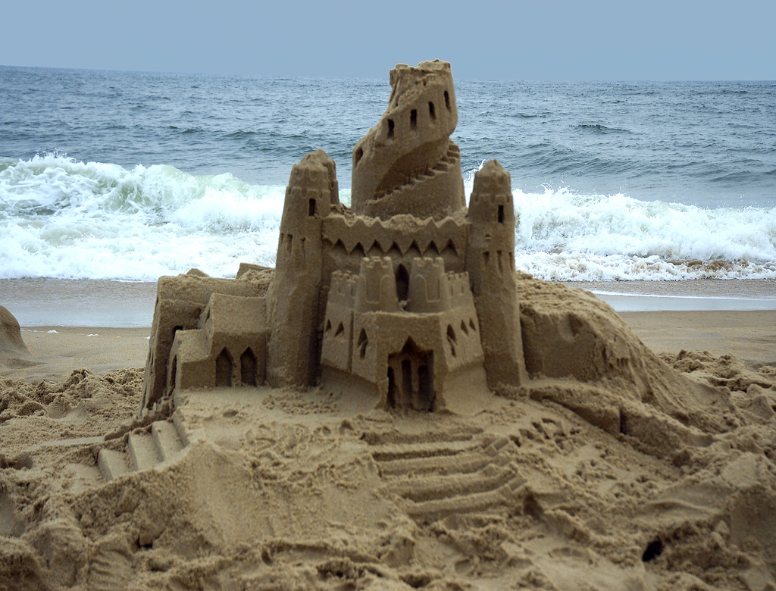
A Bedouin Tent 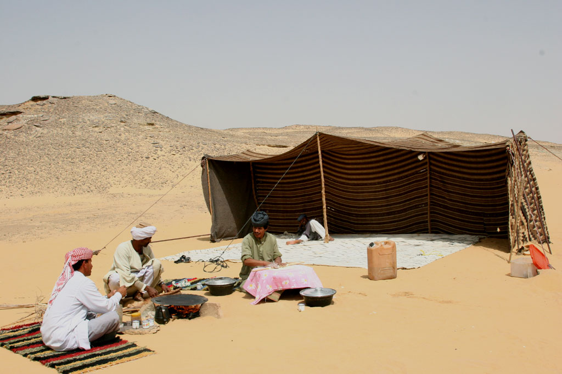 | A Recreation Vehicle - RV  
A Mobile Home  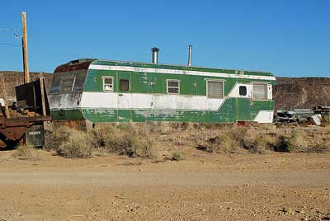 | A Monopoly House  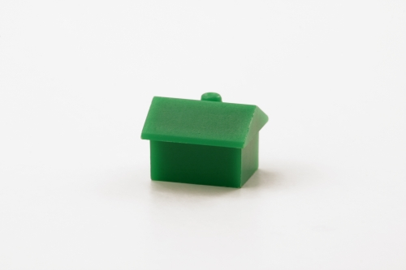
The White House   | Heidelberg Castle  